Inheritance
- It is the Process of creating a New class from an existing class.
- The Existing class is called Base or Parent class.
- The New class is called as Child or Derived Class
Advantages
- It permits code reusability. So, save time and increase the program reliability.
- Improve Program Reliability
- It Permits code sharing

Types Of Inheritance
- Single inheritance
- Multilevel inheritance
- Multiple inheritance
- Hierarchical inheritance
- Hybrid inheritance

Modes of Inheritance: There are 3 modes of inheritance.
- Public Mode: If we derive a subclass from a public base class. Then the public member of the base class will become public in the derived class and protected members of the base class will become protected in the derived class.
- Protected Mode: If we derive a subclass from a Protected base class. Then both public members and protected members of the base class will become protected in the derived class.
- Private Mode: If we derive a subclass from a Private base class. Then both public members and protected members of the base class will become Private in the derived class.

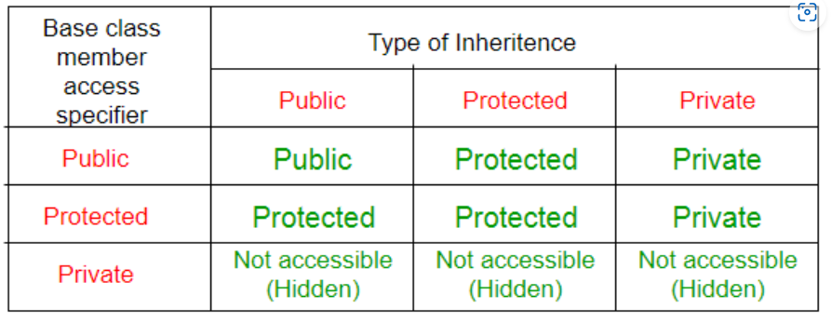

Single Inheritance

class subclass_name : access_mode base_class1, access_mode base_class2, ....
{
// body of subclass
};

class B
{
... .. ...
};
class C
{
... .. ...
};
class A: public B, public C
{
... ... ...
};

// C++ program to demonstrate implementation
// of Inheritance

#include <bits/stdc++.h>
using namespace std;

// Base class
class Parent {
public:
int id_p;
};
// Sub class inheriting from Base Class(Parent)
class Child: public Parent {
public:
int id_c;
};
// main function
int main()
{
Child obj1;

// An object of class child has all data members
// and member functions of class parent
obj1.id_c = 7;
obj1.id_p = 91;
cout << "Child id is: " << obj1.id_c << '\n';
cout << "Parent id is: " << obj1.id_p << '\n';

return 0;
}

Single Inheritance without argument

#include<iostream>
using namespace std;

class Person
{
int id;
char name[100];

public:
void set_p();
void display_p();
};

void Person::set_p()
{
cout<<"Enter the Id:";
cin>>id;
fflush(stdin);
cout<<"Enter the Name:";
cin.get(name,100);
}

void Person::display_p()
{
cout<<endl<<id<<"\t"<<name;
}

class Student: private Person
{
char course[50];
int fee;

public:
void set_s();
void display_s();
};

void Student::set_s()
{
set_p();
cout<<"Enter the Course Name:";
fflush(stdin);
cin.getline(course,50);
cout<<"Enter the Course Fee:";
cin>>fee;
}

void Student::display_s()
{
display_p();
cout<<"\t"<<course<<"\t"<<fee;
}

main()
{
Student s;
s.set_s();
s.display_s();
return 0;
}

Single Inheritance with argument

#include<iostream>
#include<string.h>
using namespace std;

class Person
{
int id;
char name[100];

public:
void set_p(int,char[]);
void display_p();
};

void Person::set_p(int id,char n[])
{
this->id=id;
strcpy(this->name,n);
}

void Person::display_p()
{
cout<<endl<<id<<"\t"<<name;
}

class Student: private Person
{
char course[50];
int fee;
public:
void set_s(int,char[],char[],int);
void display_s();
};

void Student::set_s(int id,char n[],char c[],int f)
{
set_p(id,n);
strcpy(course,c);
fee=f;
}

void Student::display_s()
{
display_p();
cout<<"t"<<course<<"\t"<<fee;
}

main()
{
Student s;
s.set_s(1001,"Ram","B.Tech",2000);
s.display_s();
return 0;
}

// Example3:

#include<iostream>
using namespace std;

class A
{
protected:
int a;

public:
void set_A()
{
cout<<"Enter the Value of A=";
cin>>a;

}
void disp_A()
{
cout<<endl<<"Value of A="<<a;
}
};

class B: public A
{
int b,p;

public:
void set_B()
{
set_A();
cout<<"Enter the Value of B=";
cin>>b;
}

void disp_B()
{
disp_A();
cout<<endl<<"Value of B="<<b;
}

void cal_product()
{
p=a*b;
cout<<endl<<"Product of "<<a<<" * "<<b<<" = "<<p;
}

};

main()
{

B _b;
_b.set_B();
_b.cal_product();

return 0;

}
// Example4:

#include<iostream>
using namespace std;

class A
{
protected:
int a;

public:
void set_A(int x)
{
a=x;
}

void disp_A()
{
cout<<endl<<"Value of A="<<a;
}
};

class B: public A
{
int b,p;

public:
void set_B(int x,int y)
{
set_A(x);
b=y;
}

void disp_B()
{
disp_A();
cout<<endl<<"Value of B="<<b;
}

void cal_product()
{
p=a*b;
cout<<endl<<"Product of "<<a<<" * "<<b<<" = "<<p;
}

};

main()
{
B _b;
_b.set_B(4,5);
_b.cal_product();

return 0;
}

Multiple Inheritance

class subclass_name : access_mode base_class1, access_mode base_class2, ....
{
// body of subclass
};

class B
{
... .. ...
};
class C
{
... .. ...
};
class A: public B, public C
{
... ... ...
};

// C++ program to explain
// multiple inheritance
#include <iostream>
using namespace std;

// first base class
class Vehicle {
public:
Vehicle() { cout << "This is a Vehicle\n"; }
};

// second base class
class FourWheeler {
public:
FourWheeler()
{
cout << "This is a 4 wheeler Vehicle\n";
}
};

// sub class derived from two base classes
class Car : public Vehicle, public FourWheeler {
};

// main function
int main()
{
// Creating object of sub class will
// invoke the constructor of base classes.
Car obj;
return 0;
}

Multi-Level Inheritance

// Example:

#include<iostream>
using namespace std;

class A
{
protected:
int a;

public:
void set_A()
{
cout<<"Enter the Value of A=";
cin>>a;

}

void disp_A()
{
cout<<endl<<"Value of A="<<a;
}
};

class B: public A
{
protected:
int b;

public:
void set_B()
{
cout<<"Enter the Value of B=";
cin>>b;
}

void disp_B()
{
cout<<endl<<"Value of B="<<b;
}
};

class C: public B
{
int c,p;

public:
void set_C()
{
cout<<"Enter the Value of C=";
cin>>c;
}

void disp_C()
{
cout<<endl<<"Value of C="<<c;
}

void cal_product()
{
p=a*b*c;
cout<<endl<<"Product of "<<a<<" * "<<b<<" * "<<c<<" = "<<p;
}
};

main()
{

C _c;
_c.set_A();
_c.set_B();
_c.set_C();
_c.disp_A();
_c.disp_B();
_c.disp_C();
_c.cal_product();

return 0;

}

Hierarchical Inheritance
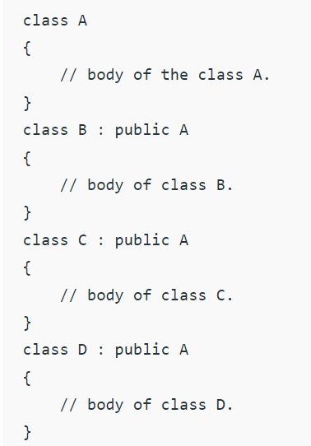

// C++ program to implement
// Hierarchical Inheritance
#include <iostream>
using namespace std;

// base class
class Vehicle {
public:
Vehicle() { cout << "This is a Vehicle\n"; }
};

// first sub class
class Car : public Vehicle {
};

// second sub class
class Bus : public Vehicle {
};

// main function
int main()
{
// Creating object of sub class will
// invoke the constructor of base class.
Car obj1;
Bus obj2;
return 0;
}

Hybrid (Virtual) Inheritance

// C++ program for Hybrid Inheritance

#include <iostream>
using namespace std;

// base class
class Vehicle {
public:
Vehicle() { cout << "This is a Vehicle\n"; }
};

// base class
class Fare {
public:
Fare() { cout << "Fare of Vehicle\n"; }
};

// first sub class
class Car : public Vehicle {
};

// second sub class
class Bus : public Vehicle, public Fare {
};

// main function
int main()
{
// Creating object of sub class will
// invoke the constructor of base class.
Bus obj2;
return 0;
}

// Example:

#include <iostream>
using namespace std;

class A
{
protected:
int a;
public:
void get_a()
{
cout << "Enter the value of 'a' : ";
cin>>a;
}
};

class B : public A
{
protected:
int b;
public:
void get_b()
{
cout << "Enter the value of 'b' : ";
cin>>b;
}
};
class C
{
protected:
int c;
public:
void get_c()
{
cout << "Enter the value of c is : ";
cin>>c;
}
};

class D : public B, public C
{
protected:
int d;
public:
void mul()
{
get_a();
get_b();
get_c();
cout << "Multiplication of a,b,c is : " <<a*b*c;
}
};

int main()
{
D d;
d.mul();
return 0;
}

A special case of hybrid inheritance: Multipath inheritance:
A derived class with two base classes and these two base classes have one common base class is called multipath inheritance. Ambiguity can arise in this type of inheritance.

There are 2 Ways to Avoid this Ambiguity:
1) Avoiding ambiguity using the scope resolution operator: Using the scope resolution operator we can manually specify the path from which data member a will be accessed, as shown in statements 3 and 4, in the above example.
// C++ program demonstrating ambiguity in Multipath
// Inheritance

#include <iostream>
using namespace std;

class ClassA {
public:
int a;
};

class ClassB : public ClassA {
public:
int b;
};

class ClassC : public ClassA {
public:
int c;
};

class ClassD : public ClassB, public ClassC {
public:
int d;
};

int main()
{
ClassD obj;

// obj.a = 10; // Statement 1, Error
// obj.a = 100; // Statement 2, Error

obj.ClassB::a = 10; // Statement 3
obj.ClassC::a = 100; // Statement 4

obj.b = 20;
obj.c = 30;
obj.d = 40;

cout << " a from ClassB : " << obj.ClassB::a;
cout << "\n a from ClassC : " << obj.ClassC::a;

cout << "\n b : " << obj.b;
cout << "\n c : " << obj.c;
cout << "\n d : " << obj.d << '\n';
}

In the above example, both ClassB and ClassC inherit ClassA, they both have a single copy of ClassA. However Class-D inherits both ClassB and ClassC, therefore Class-D has two copies of ClassA, one from ClassB and another from ClassC.
If we need to access the data member of ClassA through the object of Class-D, we must specify the path from which a will be accessed, whether it is from ClassB or ClassC, bcoz compiler can’t differentiate between two copies of ClassA in Class-D.

Avoiding ambiguity using the virtual base class:

#include<iostream>

class ClassA
{
public:
int a;
};

class ClassB : virtual public ClassA
{
public:
int b;
};

class ClassC : virtual public ClassA
{
public:
int c;
};

class ClassD : public ClassB, public ClassC
{
public:
int d;
};

int main()
{
ClassD obj;

obj.a = 10; // Statement 3
obj.a = 100; // Statement 4

obj.b = 20;
obj.c = 30;
obj.d = 40;

cout << "\n a : " << obj.a;
cout << "\n b : " << obj.b;
cout << "\n c : " << obj.c;
cout << "\n d : " << obj.d << '\n';
}

